A000-AM,C-Nicaragua-Rivas Dept.-Greater Nicoya-Figure-Female-Polychrome-

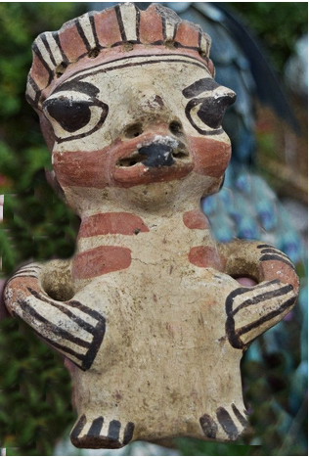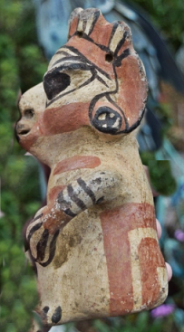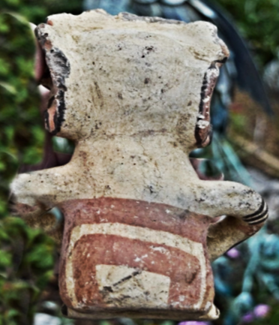

Rivas Department, Nicaragua, borders Lake Nicaragua to the east and the Pacific Ocean to the west. The southern part of the department borders with Costa Rica.

**Formal Label:**

**Accession Number:**

**Date or Time Horizon:**

**Geographical Area:** Rivas Department, Nicaragua

Map:

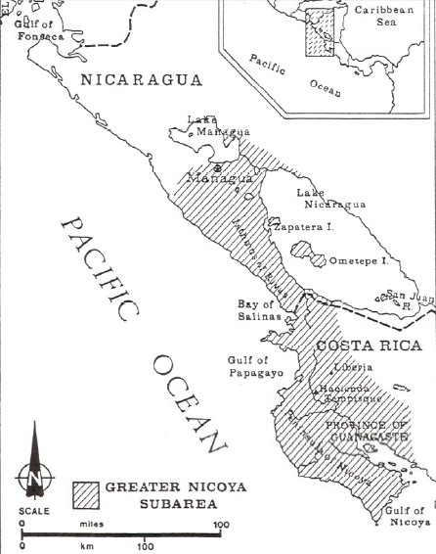

**Cultural Affiliation:** Nicoya

**Media:** terracotta, clay slip, red and black pigment.

**Dimensions:**

**Weight:**

**Provenance:** from the estate of movie director Michael Cimino.

**Dimensions:**

**Weight:**

**Condition: Original.** Some spalling on the surface shows the effects of moisture in the grave,

Discussion:

This elaborately-painted, carefully hand-modeled seated female nude ceramic figure is portrayed with polychrome brown-on-cream-colored linear and geometric body art and tattoos covering her shoulders and chest. She is posed standing with both hands akimbo.

Guanacaste-Nicoya archaeological periods follow the periodization of Lower-Central America (Lange 1996) in six periods that spanned 12,000 BCE-1550 CE/AD. This polychrome ceramic comes from **Period V** (CE/AD 500-1000) in which there was a return to exploitation of marine resources, expanding habitations, and the development of Guanacaste-Nicoya polychrome ceramics of which this is an example in the Papagayo style: a cream-colored ceramic with polychrome motifs, which was widespread after 700 CE/AD. This ceramic with the figure’s eyes closed as if in a trance suggests she is one of the ritual specialists with shamanistic powers. It was probably placed in a grave in the Linea Vieja region where juxtaposed graves have stone-lined rectangular walls and floors that have preserved many ceramics in good to excellent condition (Stone 1972: 27).

**References:**

Abel-Vidor Suzanne, Dirk Bakker, Detroit Institute of Arts, Jay I. Kislak. 198. *B****etween continents/between seas: Pre-Columbian art of Costa Ri*ca.** New York: H.N. Abrams; [Detroit]: Detroit Institute of Arts.

Evans Toby, Susan and David Webster, eds. 2001. *Archaeology of Ancient Mexico and Central America: an Encyclopedia*. New York: Garland Publishing.

Lange, Frederick W., ed. 1996. *Paths to Central American Prehistory*. Boulder: University of Colorado Press.

Stone, Doris. 1972. *Pre-Columbian man finds Central America: the archaeological bridge*. Cambridge: Peabody Museum.

*Arts précolombiens de l’Amérique centrale dans les collections du musée Barbier-Mueller de Barcelone: Nicaragua, Costa Rica et Panamá,* 2001, cat. 9, p. 163